What happens if the API you're trying to access is down for maintenance? Most modern applications take advantage of many external services. If an APi or service is not critical to the functionality of your application, the show must go on! Don't disable everything because your connection to the Google Analytics API is down.

This can be done with frontend circuit breakers, or just generally checking if services are down. Naturally, some judgement is needed to decide how to handle missing services. Completely non-critical services should fail silently, and those which fall somewhere between there and being mission critical should be disabled intelligently.

In some cases, that should be exactly what it sounds like - let your users know something is missing or offline temporarily, and disable any interface elements that might lead to that offline service breaking things. In other cases, after letting users know that something is temporarily offline, it might be better to get it out of their way - and to hide it until that service comes back online.

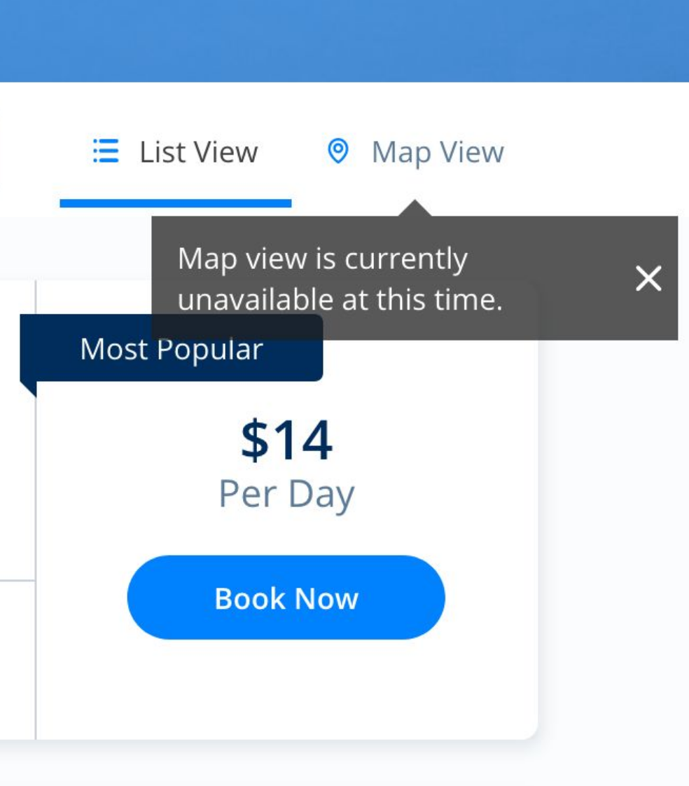 | 
While booking a parking space recently, Spothero.com’s mapping service went down. Instead of giving me a frustratingly useless map interface, it let me know the service was down, and hid the view option until the map service came back. Brilliant!

In some cases, you may be able to provide a good fallback: if your video hosting CDN is down, and you have the luxury of a backup CDN, switch to the fallback! Similarly, if you can tell that the google maps embed on your page is breaking, it might make sense to fall back to OpenStreetMap, or another similar service. If you’re loading images on your interface, having a fallback image or SVG loaded via CSS will always look better than the browser or mobile OS’s broken image placeholder.

